Lab Assignment 3-3 Linux Processes Linux+ and LPIC-1
Special Instructions: If you are using COIS-Linux.austincc.edu to do this lab, you may get error messages when attempting some of these questions. Many of the command in Chapter 9 require administrative (root) privileges and may not execute as expected. Another note: the output of the most of these commands is formatted in columns on the terminal screen and when moved to Word or a text editor the table loses its formatting. You need not try to correct it on your lab submission.
- Enter the command “ps” and show the output.
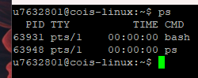
- Enter the command “ps –f” and show the output.
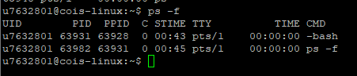
- Run the command “ps –ef” and show the results.
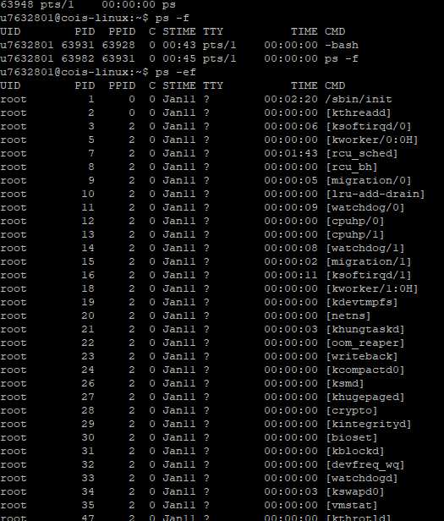
What process has the process id of 1?
The process with the process ID (PID) of 1 in the provided output is /sbin/init. This process is typically the first process started by the kernel during the boot process and serves as the ancestor of all other processes on the system.
What is show in the TTY column of most processes?
In most processes, the TTY column displays a question mark (?). This indicates that the process is not associated with any specific terminal device. Typically, processes running in the background or system processes do not have an associated terminal.
Which user started most of the processes?
The user "root" started most of the processes. This is evident from the "UID" column, where the UID (User Identifier) for these processes is 0, which is typically associated with the root user in Unix-like operating systems.

- Run the command “ps –el” and show the results?
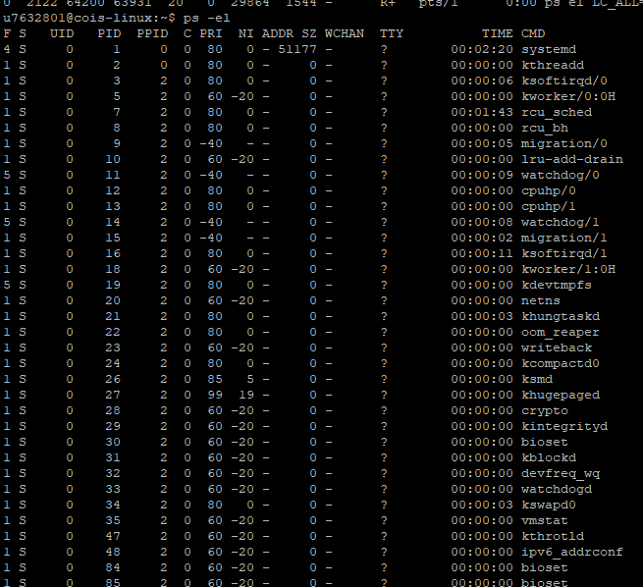

What is the process state of most processes?
The process state of most processes is "S," which indicates that they are in a sleeping state.

What does a flag of 4 mean?
A flag value of 4 typically indicates that the process has the "CLONE_STOPPED" flag set. This means that the process is currently stopped and not executing.

What is a nice value?
In the context of process management in operating systems like Unix and Linux, the "nice" value is a parameter used to prioritize the scheduling of processes. It represents the priority of a process in relation to other processes competing for CPU time. A lower nice value indicates higher priority, meaning that the process is more likely to get CPU time, while a higher nice value indicates lower priority, allowing other processes with lower nice values to get CPU time first. The nice value ranges from -20 to 19, where lower values are more favorable.

- Enter and run the command “ps ax | head -11” and show the output?

What does the “S<” mean when it appears in the STAT column.

- Enter the command “kill –l” and show the output?
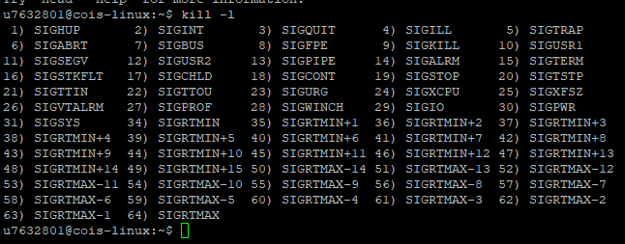

What is the SIGQUIT signal number?
The SIGQUIT signal number is 3. It is a signal sent to a process to request termination, typically initiated by the user pressing Ctrl+\ (Control backslash) on the keyboard. Unlike SIGINT (Signal Interrupt), which is commonly sent by pressing Ctrl+C, SIGQUIT is often used to terminate a process and generate a core dump for debugging purposes.

What is a SIGQUIT signal?
The SIGQUIT signal is a signal sent to a process by the operating system to request termination. It is similar to the SIGINT signal (which is generated by pressing Ctrl+C) but has a different default action. When a process receives the SIGQUIT signal, it typically terminates and produces a core dump, allowing for debugging information to be collected. This signal is commonly used when a process is unresponsive or needs to be terminated forcefully. Users can generate the SIGQUIT signal by pressing Ctrl+\ on the keyboard.

The remainder of the questions in this lab are optional. They require that you use a Linux system on which you have administrative (root) priviledges.

- Enter the command “crontab –e” and enter the following (use the vim editor if asked to select) then save and exit:
30 4 * * 5 /bin/ls –l
0 14 1 * * /bin/date

- Enter and run the command “nice –n 19 ps –l”
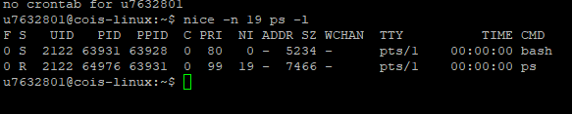
- Enter and run the command “at 10:15 Oct 15”
When you get the at> prompt enter:
at> date > /root/atfile
at> w >> /root/atfile
at> Cntrl d

- Run the command “crontab –l” and show the results?
